

NAIROBI SCHOOL 2025 PREDICTION
KCSE ANTICIPATION EXAM
451/1
COMPUTER STUDIES
PAPER 1 (THEORY)
TIME: 2½ HOURS

NAME……………………………………………………………………………………….
SCHOOL……………………………………………… SIGN………………………..
INDEX NO……………………………………………. ADM NO……………………

(Kenya Certificate of Secondary Education)

Instructions to Candidates
- Write your name and index number in the spaces provided above.
- This Paper consists of two sections A and B.
- Answer all the questions in section A.
- Answer question 16 and any other three questions from section B.
- All answers should be written in the spaces provided.
FOR EXAMINER’S USE ONLY
Section | Questions | Candidate’s score
A | 1-15
B | 16
 | TOTAL SCORE

SECTION A: (40 MARKS)
Answer ALL questions in this section
- Name any two computing devices developed during pre-electronic age. (2marks)
………………………………………………………………………………………………………
………………………………………………………………………………………………………

- Several items of data are input to a computer using direct data entry methods. Write down the most appropriate input device to input each item of data.
- Data written in special ink at the bottom of bank cheques. (1mark)
………………………………………………………………………………………………………
- Information on the label of a supermarket product. (1mark)
………………………………………………………………………………………………………
- Shaded in boxes on a student’s examination answer sheet. (1mark)
………………………………………………………………………………………………………
- Debit card details input at an ATM. (1mark)
………………………………………………………………………………………………………

- Differentiate between a monitor and a printer in terms of information output. (2marks)
………………………………………………………………………………………………………
………………………………………………………………………………………………………
………………………………………………………………………………………………………
………………………………………………………………………………………………………

- Kilimambogo has decided to create a new file using an application program. He added content in the file. Identify the type of storage device that he was using while creating the file. (1mark)
………………………………………………………………………………………………………

- Kilimambogo decided to save the file after adding content. Identify the type of storage device he used. (1mark)
………………………………………………………………………………………………………

- Describe three types of computer buses (3marks)
………………………………………………………………………………………………………
………………………………………………………………………………………………………
………………………………………………………………………………………………………
………………………………………………………………………………………………………
………………………………………………………………………………………………………

- Describe the following concepts as used in applications.
- Automatic recalculation. (2marks)
………………………………………………………………………………………………………
………………………………………………………………………………………………………
………………………………………………………………………………………………………

- What if analysis. (2marks)
………………………………………………………………………………………………………
………………………………………………………………………………………………………
………………………………………………………………………………………………………

- Password is a secret code for protecting systems against unauthorized access. State three features of a password. (3marks)
………………………………………………………………………………………………………
………………………………………………………………………………………………………
………………………………………………………………………………………………………

- Explain the following terminologies used in an e-mail software.
- CC (2marks)
………………………………………………………………………………………………………………………………………………………………………………………………..…
- BCC (2marks)
………………………………………………………………………………………………………………………………………………………………………………………………

- Identify the data processing modes that are used in performing the following activities:
- Processing examination marks for students in a school. (1mark)
………………………………………………………………………………………………………

- Booking a bus ticket using computing device and choosing a specific seat. (1mark)
………………………………………………………………………………………………………

- Buying of data bundles using a software that provides the user with immediate response to enable the user to decide and make a selection for the next input. (1mark)
………………………………………………………………………………………………………

- Name three types of non-printing guides in DTP. (3marks)
………………………………………………………………………………………………………
………………………………………………………………………………………………………
………………………………………………………………………………………………………

- State two advantages of USB ports over COM ports. (2marks)
………………………………………………………………………………………………………
………………………………………………………………………………………………………

- A supermarket decided to computerize their system. State three benefits that the supermarket would realize by doing this. (3marks)
………………………………………………………………………………………………………
………………………………………………………………………………………………………
………………………………………………………………………………………………………

- Kimani wanted to buy an application software, he was advised to buy an integrated package. What is meant by the term integrated software. (2marks)
………………………………………………………………………………………………………
………………………………………………………………………………………………………
………………………………………………………………………………………………………

- Explain three benefits that Kimani would experience by using an integrated software other than the single package. (3marks)
………………………………………………………………………………………………………
………………………………………………………………………………………………………
………………………………………………………………………………………………………
………………………………………………………………………………………………………
………………………………………………………………………………………………………
………………………………………………………………………………………………………
………………………………………………………………………………………………………

SECTION B: (60 MARKS)
Answer Question 16 and any other three questions from this section
16. (a) Explain the term structured programming as used in program development. (2marks)
(b) Name the stage of program development in which: (4marks)
(i). A flowchart would be drawn.
(ii). The programmer would check whether the program does as required.
(iii). User guide would be written.
(iv). The requirement specification would be written.

(c) State two function of an assembler. (2marks)
(d) To qualify to play in football tournament, a student must be aged between 13 and 18, the system automatically checks a player’s age once their names and date of birth have been provided. 11 participants were evaluated and their qualification status displayed alongside their name and age. Draw a flowchart that would be used to create the program. (7 marks)

17. a) . State three ways in which an operating system performs error handling in a computer system. (3marks)

b). An operating system organizes files in directories as shown in the chart below. Study it and answer the questions that follow.
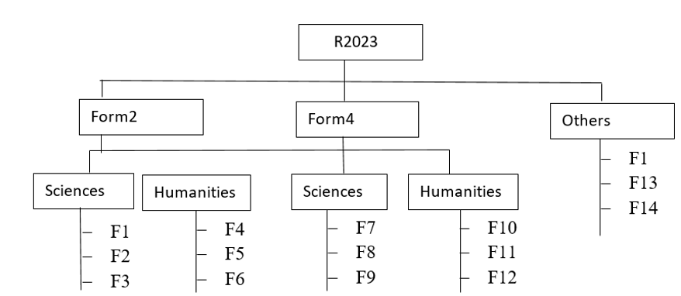
(i) Write the name of this file structure? (1mark)
(ii) Explain what would happen if an attempt is made to delete Form4 while F10 in Humanities is opened. (2marks)
(iii) Write the path of the F6. (2marks)
(c) Describe three activities that are performed in the maintenance phase during system development. (6 marks)
(d) State one role of an information system analyst. (1mark)

18. (a) What is meant by the term data communication? (1mark)
(b) Describe three data communication elements (3marks)
(c) State the meanings of the following network and internet terms: (5marks)
- Protocol
- Client
- Server
- Home page
- DTE

(c) With aid of a diagram, describe the star network topology (6marks)

19 (a) Define each of the following computer terminologies (2marks)
- Nibble
- Byte
(b) State three ways of reducing Repetitive Strain Injuries when using computers. (3marks)
- Using twos compliment, perform the following binary arithmetic leaving your answer in decimal notation.
1101₂ – 100101₂ (6 marks)
- The diagram below shows how mail merging is done in word processing. Use it to answer the questions below.
File X
……<<adm>>…..………………………..<<name>>……………<<house>>.
Adm | Name | House

Merge process
………..
………..
………………………………………………………………
File W
File Z

Identify the files labeled: (3marks)
- W ………………………………………………………………………….
- X …………………………………………………………………………..
- Z …………………………………………………………………………..
(e) Name the terminology used to refer to items enclosed in << >> symbols in file W. (1mark)

20. (a) Explain three components of an Expert System. (6marks)
(b) The following is an extract from a database obtained from a National organization. Use the table to answer questions which follow:
S/NO | EMPLOYMENT ID | NAME | AGE | DEPARTMENT | SALARY(SH) | STATUS
001 | EMP01 | Lucy | 40 | Secretary | 40,000 | Married
002 | EMP02 | Agnes | 45 | Cook | 20,000 | Single
003 | EMP03 | Peter | 30 | Messenger | 15,000 | Married
004 | EMP04 | Joel | 35 | Account | 50,000 | Married
005 | EMP05 | Abdi | 20 | Sales | 45,000 | Single
006 | EMP06 | Baraka | 25 | Security | 10,000 | Single

(i.) Which field could best fit to be a primary key? (1mark)
(ii) Explain your answer in (i). (2marks)
(iii)Describe how they would extract all the details of those who are 30 years and above and are married. (3 marks)
(c) State three area where virtual reality can be applied. (3marks)

